***Data Structures and Algorithms (Project Report)***

***Name = Poorab Gangwani***

***Class = 3B***

***Roll-Number = CS191092***

***Group Members = Poorab Gangwani (CS191092)***

***Project Subject = Accounts and Money Transaction System & Hangman Game***

***Front – End Design (Hangman Game):***

The layout and design of the hangman game comprises of the basic features associated with the game implemented through C++ Programming language and consist of the following:

**Hangman diagram**: which slows builds up when you give wrong guesses and was built with the help of charcode.

**Guess-Hint Box:** hints that act as possible indicators to the right word that is to be guessed will be displayed lined format.

**Underlined-Blanks:** blank line spaces that will be filled if the right character is guessed.

**Wrong-Guess-Display:** as the game proceeds, any wrong guesses you input will be noted and will be shown in a separate line display in collection.

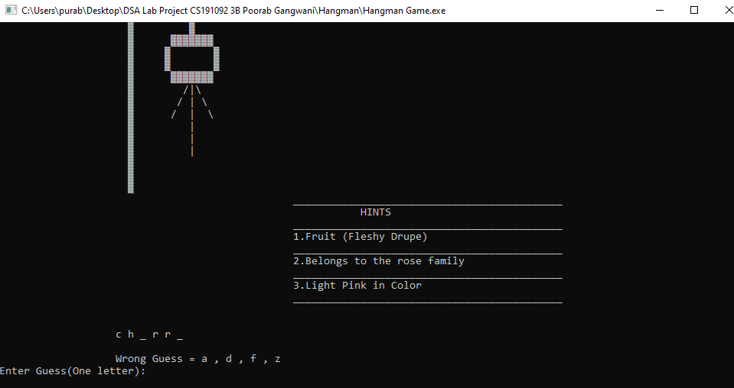

**Back-End Code (Hangman Game):**

The game was implemented through the use of the data structure of arrays and the libraries such as iostream and stdlib were used.

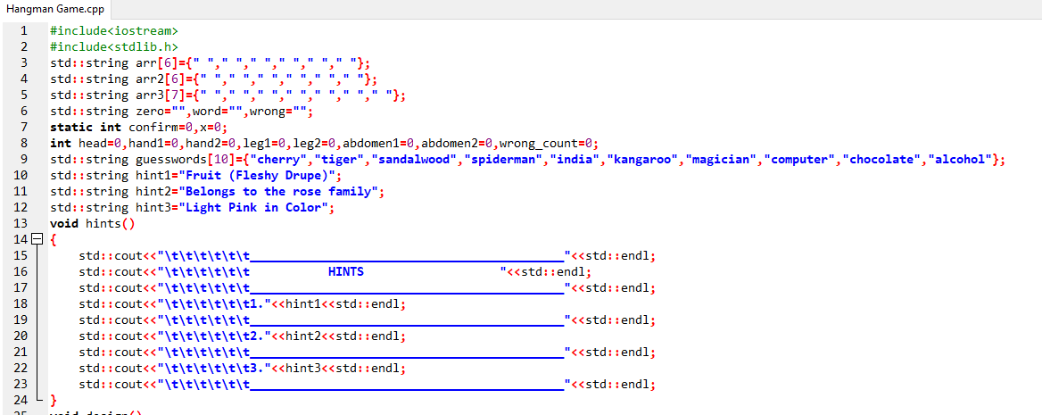

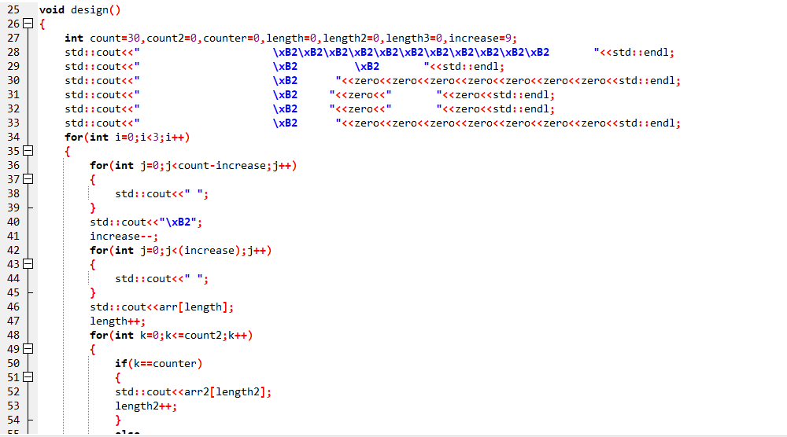

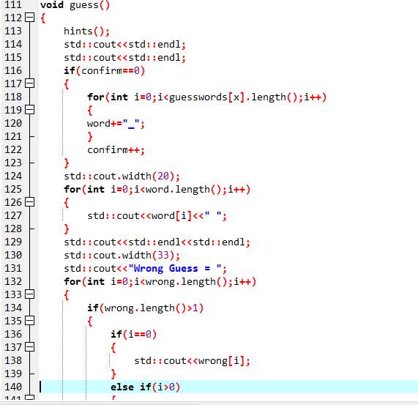

**Accounting and Money Transaction System:**

**Front End Design:** The front end appearance of the Program comprises of the features associated with the subject in type. The data structures of lists and stacks were used in the designing of the program and it’s side applications.

It displays a set of options:

1. **Create Account:** which will require your personal information and account preferences such as password be stated and will assign you your Account Number.
2. **Information Amendment:** it will give the option to perform emendations on your already submitted data or perform money transactions (Transfer of amount, withdrawal, Deposit Amount).
3. **Delete Account:** this feature gives you the choice to close your account which will automatically erase your funds and complete personal information.
4. **Money Transaction:** it will allow you the service of transferring or depositing your money and checking your balance.
5. **Accounts-Overview:** it will allow you to view the complete records of all the account holders and there Account Information.

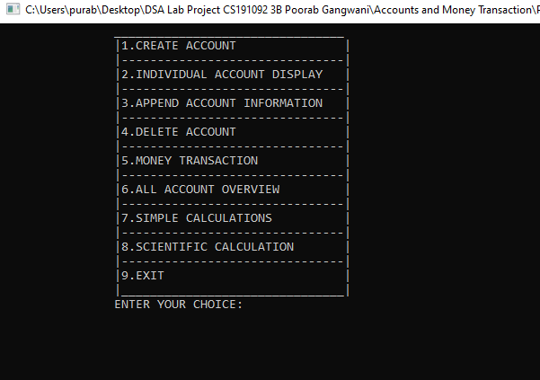

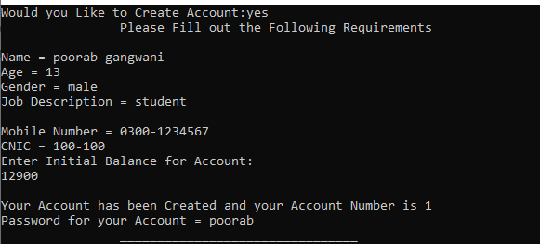

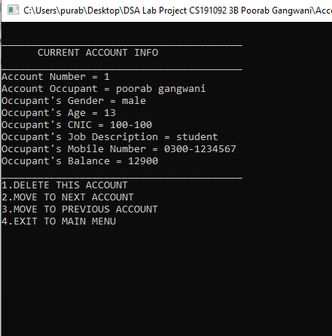

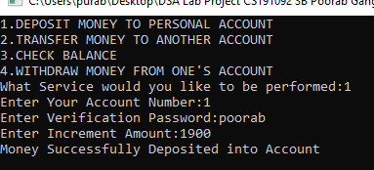

**Auxiliary Features**

1. **Simple Calculator:** it can be used for calculations and has been implemented using data structure of stacks.

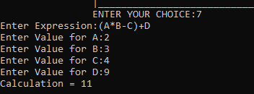

1. Advanced Calculator: this can help in further calculations such as square root , Sin , Tan , Cos and others.

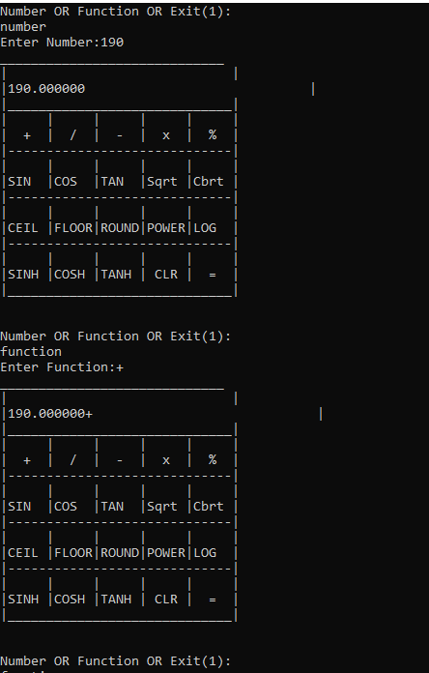

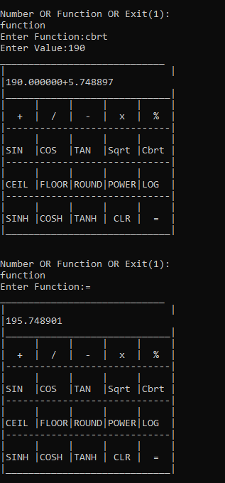

**Backend Code (Accounting and Money Transaction System):**

This Program was designed with the data structures of stacks (Push,Pop) and doubly linked list.

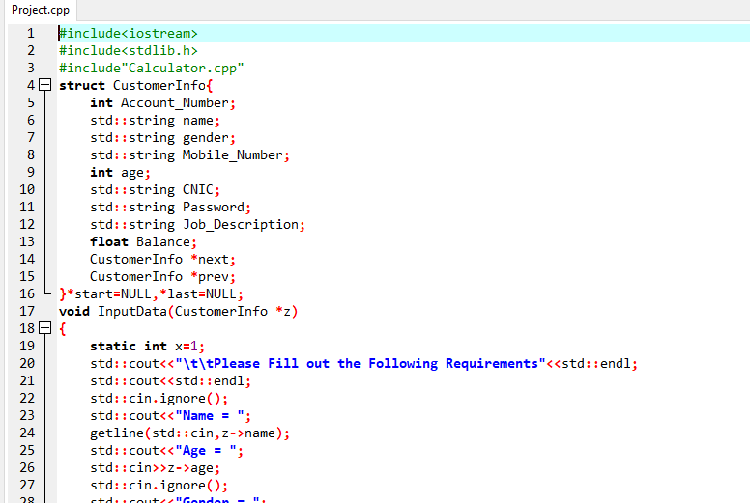

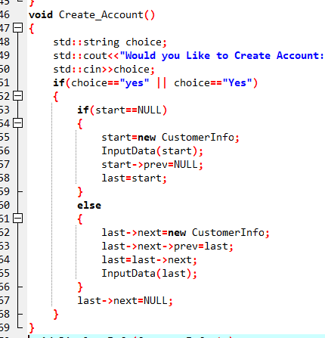

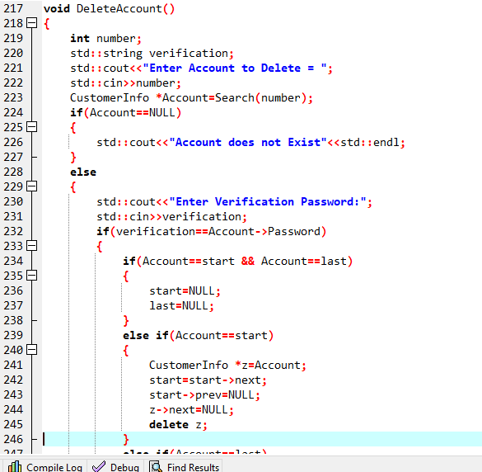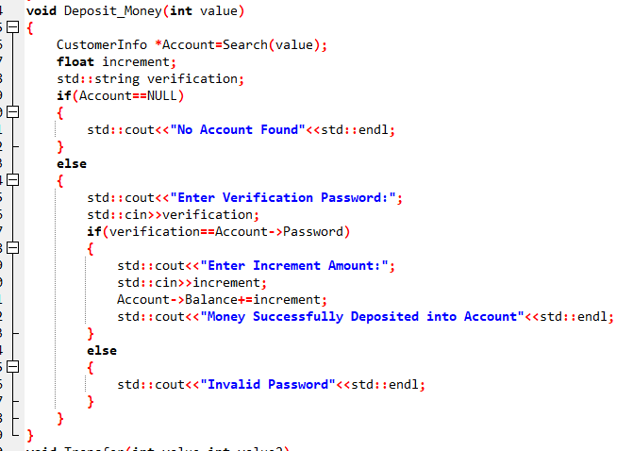

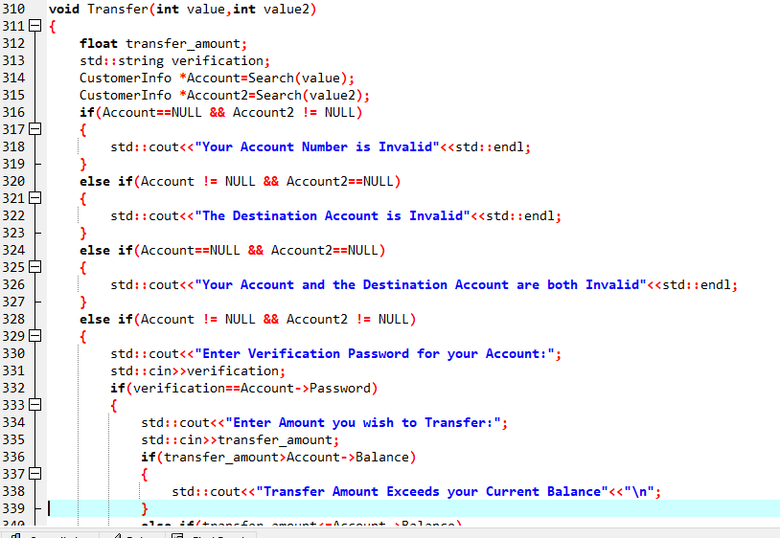

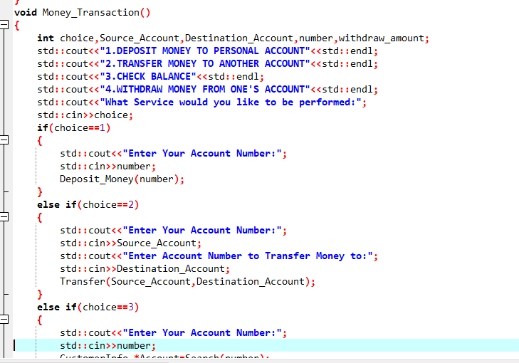

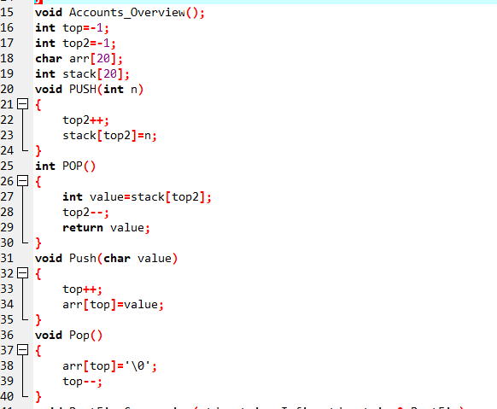

***Flowchart of Programs:***

